True North Technologies

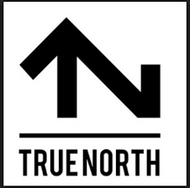

Southwell Architects Project

4/26/18

Table of contents

Introduction 2

Current State Analysis 3

Narrative Description 4

Logical Diagram 5

Physical Diagram 6

Equipment Description 7

Budget 8

Provision for Maintenance 9

Request for Contract 10

References 11

Introduction

True North Technologies is an exciting new forward-thinking company providing quality office network installation for a variety of businesses in the Gainesville area. Our experienced team of architects, engineers, and information technology professionals is comprised of college graduates who pride themselves on the ability to capture the vision of the client and to make sure that the job is done right the first time.

Using a tried and tested method of communication and attention to detail, we will work tirelessly to make sure that you’re comfortable with the plan before we take the first step. While we prefer to work as quickly as possible to accomplish your goal, we offer flexible scheduling options to work around business hours to not interrupt your workflow. We are licensed and insured and stay ahead of the latest guidelines and standards to make sure our work will hold up for years to come.

Current State Analysis

Southwell Architects is moving into a new office space composed of 11 rooms, a reception area, and a rest area. They will need a network to support approximately 30 employees including an audio and video conferencing system and wireless access throughout the building. The software commonly used includes Microsoft enterprise applications and AutoCAD. The deadline for the work will be in line with the move-in date of June 1st, 2018.

Narrative Description

True North Technologies will design a network starting at the DMZ and will work with the ISP to maximize the available bandwidth. We will supply, configure, and install (30) Computers, (30) Monitors, (20) Tablets, (30) VoIP Phone Systems, (2) Video Conferencing Systems, (2) Audio Conferencing Systems, (9) 50” Smart TV’s, (4) Color Scanners, (4) Color Laser Printers, (4) Color Inkjet Printers, (2) 3-D Printers, (3) Xerox All-In-One Work Centers, (1) Touchscreen Kiosk, (2) Drafting Plotters, (10) switches, (3) wireless routers, (10) Security-Enabled USB Devices, as well as the cabling and cable management necessary. We will also provide a 1-year maintenance agreement to remedy any hiccups encountered after installation.

**This plan is operating under the assumption that you’d like to reuse your current network server. We have included the option to replace the server in the detailed budget below.

Logical Diagram

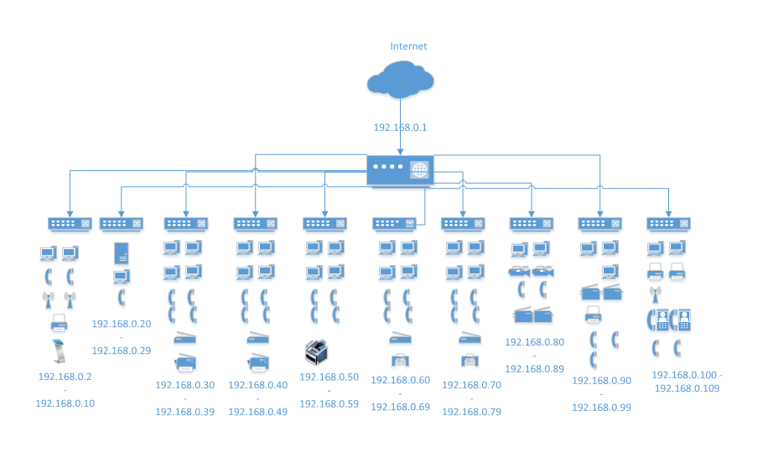

Physical Diagram

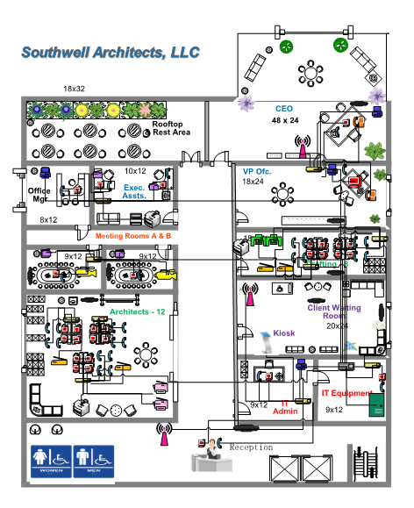

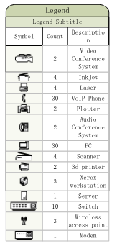

Equipment Description

**Desktop Computers/Monitors**

* Machines powerful enough to run the required software and monitors capable of showing the details.

**Tablets**

* The iPad Pro is strong enough to handle necessary office programs on the run.

**VoIP/Video Conference Systems/Audio Conference Systems**

* The communication hardware necessary to keep your entire team on the same page.

**Smart TV’s**

* TV’s with the ability to browse the internet. Never be out of the loop

**Scanners**

* For inputting information

**Printers**

* Strong enough to show fine detail in plans

**3d Printers**

* Helping your team and your clients see your vision.

**All-In-One Machines**

* Powerful enough for teams to share

**Touchscreen Kiosk**

* The easiest way for your clients to input information

**Plotters**

* For printing full-size blueprints

Budget

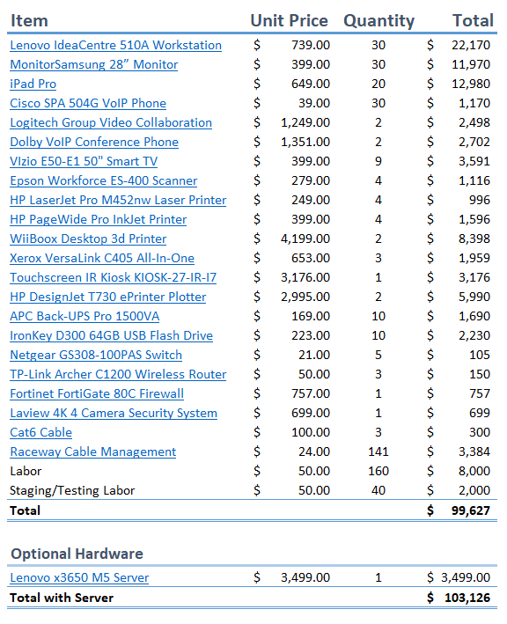

Provision for Maintenance

True North Technologies offers technical support for any issues that may arise after installation. Our team of experienced technicians can solve most issues over the phone, but in a case of a more complicated at-fault issue we will dispatch one of our commercial enterprise technicians to your location to handle the situation. The different options for support are:

* **Gold** – You will receive our “Red Carpet Hotline” number which is open 24/7 to answer and questions or solve any problems that may arise with the TRUE NORTH TECHNOLOGIES installed hardware.
  + 10% of Total Project Cost
* **Silver** – You can contact us using our response hotline with any questions or concerns with the TRUE NORTH TECHNOLOGIES installed hardware Monday through Friday from 8-5 Eastern.
  + 7% of Total Project Cost
* **Bronze** – You can contact our technical support team using the chatrooms, or you can send an email and our team will respond with a few possible causes and solutions.
  + 4% of Total Project Cost

Request for Contract

After reviewing the above documents and quoted prices for equipment and goods, I am hereby giving the intention of entering into a contract with TRUE NORTH TECHNOLOGIES. By signing below, I am formally requesting an official contract proposal from True North Technologies.



References

## Newegg.Com

* Workstations
* Monitors
* TV’s
* 3d Printers
* Switches
* Wi-Fi Router
* Security System

## Apple.com

* iPads

## TritonDatacom.com

* VoIP Phones

## Logitech.com

* Video Conference Equipment

## CDW.com

* Audio Conference Equipment
* Storage Devices
* Firewall
* Cable Management
* Server

## OfficeDepot.com

* Scanner
* Laser Printer
* Inkjet Printer

## Amazon.com

* Xerox Machines
* UPS

## Touchwindow.com

* Kiosk

## TheWideFormatCompany.com

* Plotters

## CableWholesale.com

* Cables